Hero
The Building Intelligence Center for Operators, Occupiers and Owners.
Talk to Your Building. Get Insights. Take Action.
Our Building Intelligence Center combines agentic AI with experts in the loop to turn scattered building data into clear actions that improve both energy efficiency and comfort experience across your portfolio.
Product visual: Interactive demo environment
Logo Banner
[Adrian] [Colliers] [EDGE] [JET] [Pimco] [Merlin][more][more][more] (i.e. ING, MSFT, Timeless, CBRE)
Problem
Complexity of building installations and user demands are out of reach for human execution.
Buildings generate lots of data, but it's scattered across different systems and vendors, hard to extract and nearly impossible to make sense of. Users of buildings have almost daily alternating demands. Teams can’t catch-up, instead they manage reactively, only finding out about issues when a complaint arrives or something breaks.
Solution + how it works
From scattered data to clear action.
The BIC is where agentic AI and building performance experts work together to turn fragmented building data into measurable improvements you can trust and scale in your portfolio.
Agentic AI
Our in-house developed AI agents run 24/7, each handling a specific task for faster, more accurate analysis. Together they flag issues and feed insights to our Building Performance Experts.
Building Performance Experts
Unlike AI-only platforms, every recommendation is reviewed and validated by our experts with years of building physics knowledge, so you can always trust the advice and know where to act next.
What's inside the BIC
1. * Insights*
Get a snapshot of your building’s performance
See energy, comfort and space utilization across your building or entire portfolio in one live view, and quickly spot what needs attention.
2. *Alerts*
Stay ahead of issues before they escalate
Get notified the moment a comfort issue or unusual energy pattern is detected, so you can act before it becomes a complaint or a cost.
3. *AI Building Assistant*
Ask your building, get instant answers
Instead of digging through dashboards, ask questions directly from the AI Building Assistant and get fast, clear answers.
4. *ECM Tracker*
Improve and track results
See a prioritized list of actions from our Building Performance Experts, ranked by impact, and track every action from recommendation to verified results.
5. *Building Performance Benchmark*
See how your building really compares
Benchmark your building's energy, comfort and carbon metrics against peer buildings and regulatory standards, and see exactly where you stand.
Data Foundation
The data foundation that makes it all work
Connect any building
BIC connects to any building system, from modern sensors to legacy infrastructure and mixed-vendor environments.
Always have complete data
BIC continuously monitors all live connections and audits their health, so that analysis is based on complete, accurate data.
Be warned when data fails
With the 24/7 measurement and verification services turned on, the BIC4000 can signal you when third parties disrupt signals, installations, disconnect gateways, or when other errors occur, like energy meters sending messages with zero data.
[Learn more]

One BIC. Three lenses.
Built for every stakeholder in commercial real estate
Whether you own the building, operate it, or work in it, the BIC gives every stakeholder the visibility you need to make the buildings perform well.
- For Occupiers
- For Owners
- For Operators

Social proof
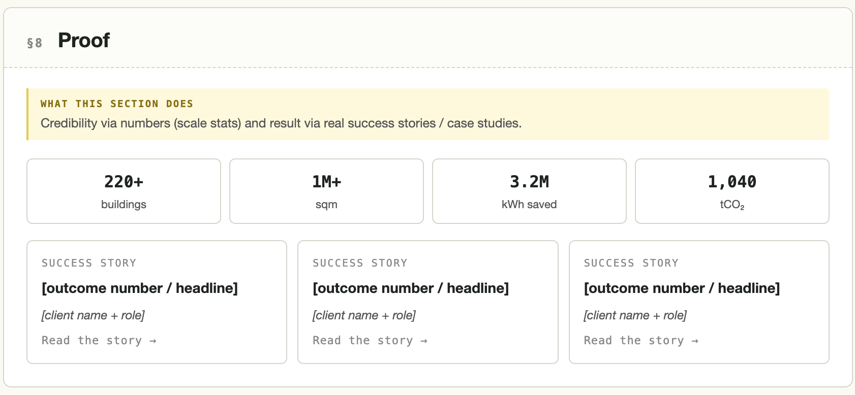

Final CTA (TBD)
Scattered data and non-performing assets?
We connect the dots. You get the benefits.
Button: Book a demo

